

FDA approves JNJ’s Icotyde for the treatment of adults and adolescents (12+ years) with moderate-to-severe plaque psoriasis

Company: JNJ  Drug: ICOTYDE (icotrokinra, oral IL-23R antagonist) | Date: March 18, 2026  Source(s): JNJ Press Release, JNJ Multimedia News Release, Protagonist Press Release, Protagonist Presentation, FDA label, Protagonist Webcast, Patient and HCP websites

What happened:
- JNJ & Protagonist announced the FDA approval of ICOTYDE 200mg QD for the treatment of adults and adolescents aged 12+ years weighing at least 40 kg with moderate-to-severe plaque psoriasis who are candidates for systemic therapy or phototherapy
- Approval based on ICONIC-LEAD, ICONIC-TOTAL and ICONIC-ADVANCE 1 & 2 that met all primary endpoints and demonstrated a favorable safety profile in 2,500 patients
- Patient and HCP websites are now available
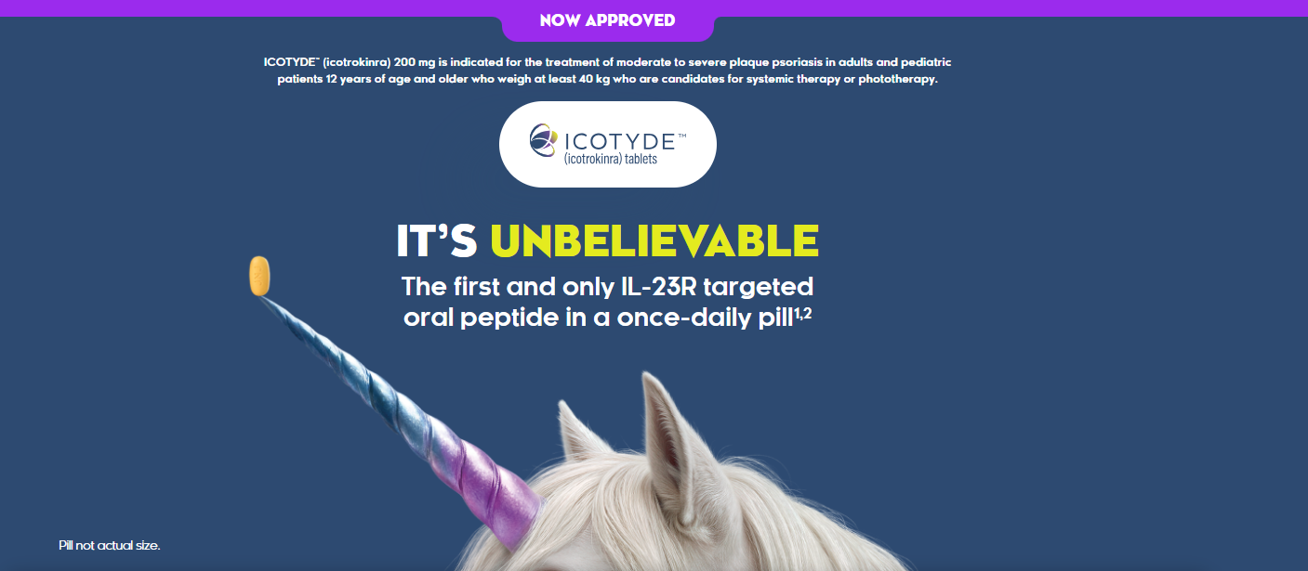
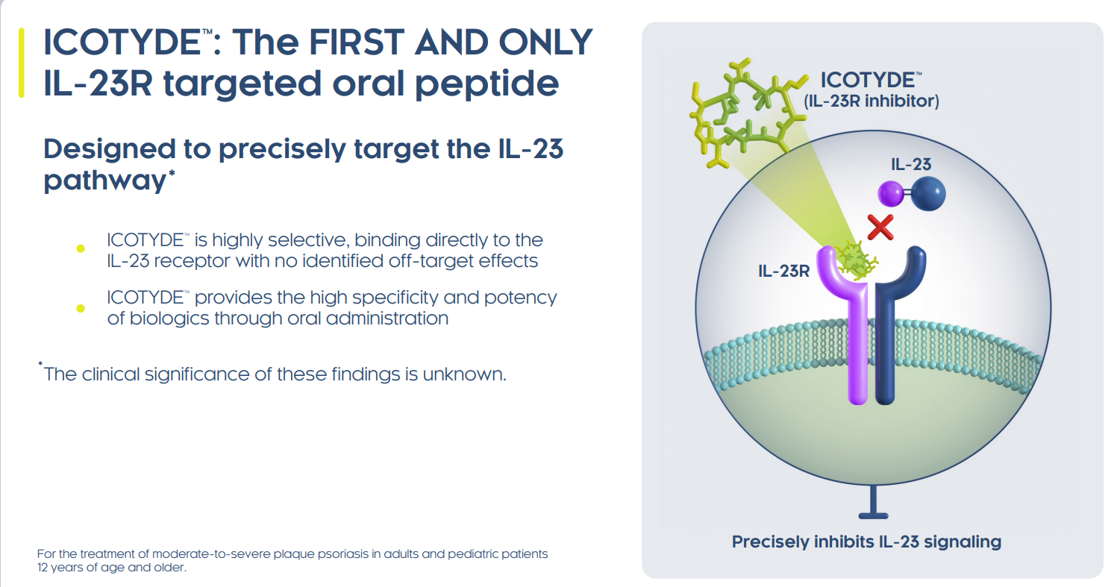
- ICOTYDE withMe will offer a comprehensive patient support program with cost support options, a dedicated Nurse Guide and educational resources; however, it is not yet live on the JNJ withMe portal

Impact (CI PoV): HIGH
- JNJ believes ICOTYDE’s approval introduces “the first and only targeted oral peptide that precisely blocks the IL-23 receptor with no identified off target effects” delivering complete skin clearance and favorable safety profile in QD oral pill
- JNJ expects ICOTYDE to alter current treatment sequencing in PsO, particularly among patients eligible for systemic therapy but not yet escalated beyond topicals
- Per JNJ, ICOTYDE is also likely to expand the systemic-treated population, particularly among biologic-naïve and injection-averse patients, given its oral profile and efficacy
  - Updated guidance from the International Psoriasis Council (IPC) and ICOTYDE’s profile may create a clearer trigger point for earlier systemic initiation, helping accelerate movement out of topical cycling and into systemic treatment in appropriate patients

Why it matters
- The approval establishes a new modality in PsO via oral IL-23 pathway targeting, while also supporting JNJ’s broader immunology strategy as it looks to sustain growth and help offset pressure associated with Stelara LOE
- JNJ is trying to establish ICOTYDE as a “unique, game-changing” treatment that is “marking a transformative shift in PsO” by “setting a new standard”; JNJ is aiming to “empower patients and clinicians to reach their treatment goals”
Tell me more:
- Dosing & Administration:
  - 200 mg oral QD
  - With water upon waking up an empty stomach, 30 minutes prior to eating food
  - Of note: For patients who have difficulty swallowing tablets, ICOTYDE can be dispersed in water
- TB Evaluation Language: Consider evaluating TB prior to initiating treatment with ICOTYDE based on clinical judgment
- Safety Considerations:
  - Box Warning: None
  - Use in Specific Populations: Moderate or Severe Renal Impairment: Monitor for potential adverse reactions in patients with eGFR <60mL/min
  - Common AEs (≥1%): Headache, nausea, cough, fungal infection, and fatigue (≥1%)
  - Across all ICONIC studies, pooled safety data showed a similar proportion of patients experienced AEs between ICOTYDE (49.1%) and placebo (51.9%) group
- Clinical Highlights: Includes Deucra H2H, scalp and genital data in label
- Food Effect Language: AUC decreased by 43% and Cmax decreased by 59% following administration with a high-fat meal (1000 calories, 50% fat). No clinically significant differences in PK following administration of caffeine
- Language from Press Release:
  - First and only targeted oral peptide that precisely blocks the IL-23 receptor
  - New era for 1L systemic treatment of plaque psoriasis with a targeted oral peptide
  - First and only IL-23R targeted oral peptide that delivers complete skin clearance and favorable safety profile in a once-daily pill
  - Innovative new option to address patients cycling on topical therapies in need of systemic treatment
- Outlook
  - H2H vs Stelara: Phase 3 ICONIC-ASCEND trial (PCD: March 30th, 2026); With trial recruiting ahead of schedule, topline data readout imminent
    - ICONIC-ASCEND, though not included in the filing package to the FDA, is expected to serve as a differentiator by demonstrating superiority over an established injectable enhancing physician adoption and payer negotiations.
  - PsA: Data from ICONIC-PsA anticipated in 2026. Earliest US approval estimated in Q2 2027, if JNJ submits based on ICONIC-PsA 1 (PCD May 2026)
  - IBD: Ph3 ICONIC-UC (PCD Jan 2028) and Ph2b/3 ICONIC-CD (PCD Sept 2028) studies; US/EU approvals projected for Q1 2029 and Q4 2029, respectively
- EU Outlook
  - On September 11th, 2025, JNJ announced submission to the EMA in 12+ years with moderate-to-severe PsO
    - CI anticipates earliest EU regulatory approval in Q3 2026
- Protagonist Commentary and Milestones
  - In a webcast accompanying the approval announcement, Protagonist management suggested the fasting requirement is unlikely to be a major barrier to adherence, pointing to patient satisfaction, early symptom relief, once-daily oral dosing and strong long-term persistence data
  - Management also expressed confidence in upcoming ICOTYDE readouts across additional indications, while deferring specific commentary on label implications, disclosure timing and commercialization strategy to JNJ
  - FDA approval of ICOTYDE triggers a $50M milestone payment to Protagonist; the company also remains eligible for up to $580M in additional regulatory and sales milestone payments, alongside tiered royalties of 6% to 10% on global net sales, corresponding to 7.25% on a weighted-average basis at $4 billion in annual sales, with the top royalty tier of 10% applying to sales above $4 billion

For questions, please reach out to:
 | Dermatology | Rheumatology | Gastroenterology
APEX (US/PCS) | Chanda Bhat | Bethany Christmann | Luke Versten
IMABI (International/ Affiliates) | Priti Anand | Irene Knorn | Priti Anand

Invite your colleagues to inVision | Manage Email Preferences | Unsubscribe

This document/email contains competitive intelligence collected via an approved competitive intelligence supplier working on behalf of AbbVie. We collect competitive intelligence consistent with industry standards and AbbVie policy. Not for field distribution. Please reach out to APEX/IMABI, Legal, or OEC teams with any questions.

